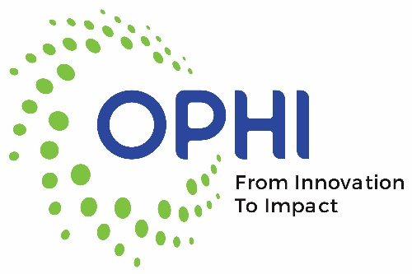
Board Member Opening

The Ohio Public Health Institute (OPHI) is accepting letters of interest for one available at-large position on the Board of Directors representing the interests of public health in Ohio. The term will be January 1, 2025 – December 31, 2026.

To be considered for this position, please send a letter of interest to OPHI. Include your name, address, email address, phone number, a list of your qualifications and the reason for your interest in serving on the Board.
Send the letter to: Susan Tilgner, OPHI Executive Director
tilgnersusan@gmail.com
Deadline to Apply: Open until filled

The mission of OPHI is to promote and strengthen public health through a sustained collaboration of Ohio’s public health community serving as experts, advocates and leaders. OPHI is Recognized by the National Network of Public Health Institutes (NNPHI) and is a member of the Public Health Accreditation Board (PHAB) Center for Innovation, 21C Project (Public Health in the 21st Century). Our work includes advancing public health practice and making systematic improvements in Ohio public health.

